I can properly add text into the text box and then press the add text button to add it to the list. I can also press the Check tasks button to make it appear as complete with a check mark to the left of the text 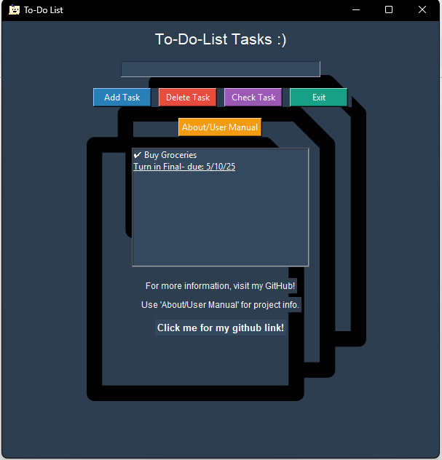

I can also press the Delete Task button to delete a highlighted task. If a task is not highlighted and you try to press delete, it will pop up an error message 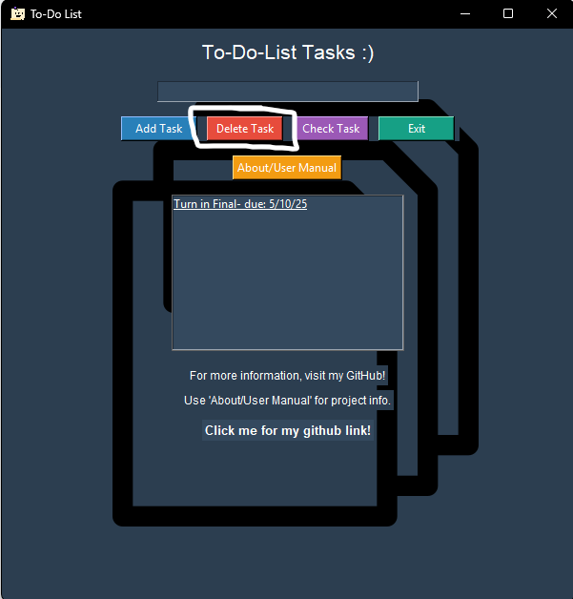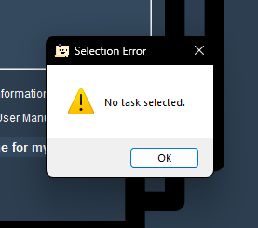

If I choose to exit the program using either the X in the top right or the Exit button, the program successfully closes itself.

I didnt have to fix anything that I know of, as I did these tests after I fully completed my program, knowing everything workes fine to my knowledge